sStock Control
Class Model

Date | July 18th, 2011
Version | 1.0
Status | Pending
Author | Trinh Duc Tam, Developer
Reviewed by | Nguyen Thi Thanh Thuy, Project Manager
Approved by | Nguyen Thi Thanh Thuy, Director

Revision History

Date | Version | Description | Author
July 18 | 1.0 | Create | Trinh Duc Tam

Table of Contents
1 Introduction 4
1.1 Purpose 4
1.2 Scope 4
1.3 Definitions, Acronyms and Abbreviations 4
1.4 References 4
1.5 Overview 4
1.5 5
2 Class Model Detail 5
2.1 Stock Control Model 5
2.1.1 Item 5

Introduction

Purpose

This is document describes the Class model of Stock Control

Scope

Definitions, Acronyms and Abbreviations

No | Term | Description

References

Overview

Class Model Detail

Stock Control Model

Type:
Status: Proposed
Package: Class Model Keywords:
Detail: Created on 03/29/2012. Last modified on 03/30/2012.

EbookStore - (Logical diagram)

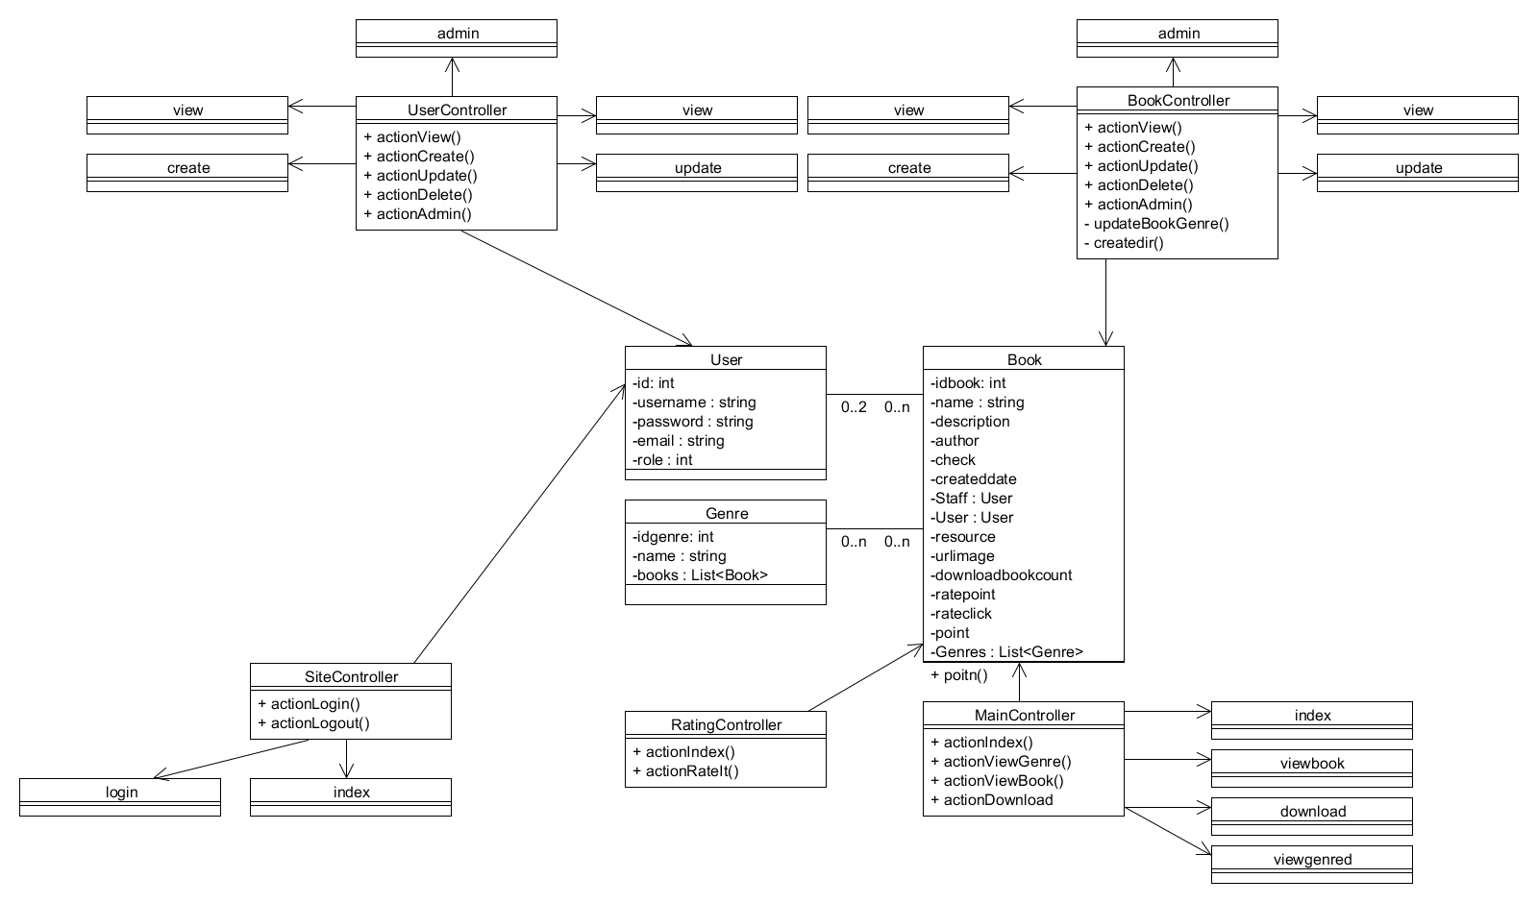

Item

Type: Class
Status: Proposed. Version 1.0. Phase 1.0.
Package: Class Model Keywords:
Detail: Created on 07/18/2011. Last modified on 07/18/2011.

Custom Properties

Connections
Connector | Source | Target | Notes

Attributes
Attribute | Notes | Constraints and tags

Operations
Method | Notes | Parameters

